World War II
The War that Changed the World
The Road to World War II
- Treaty of ___________________ ended _______________________
- It was not based on Wilson’s Fourteen Points and enraged some countries

Germany - ______ ______ Clause and ________________

Italy – didn’t get the ______ they wanted

Japan – didn’t get all of the _______ they wanted

Soviet Union – Left out of the __________
Why? (Underlying causes of WWII)
Treaty of Versailles
Germany lost ______ to surrounding nations
War Reparations
Allies collect $ to pay back war debts to U.S.
_______ must pay $57 trillion (modern equivalent)
___________ the German economy & embarrassed Germans
Why? (Underlying causes of WWII)
World-wide Depression
The Depression made Germany’s debt even _________
___________ people turn to any _______ who promises a return to ______ ______
__________ seemed to provide solutions to Germany’s problems
Why? (Underlying causes of WWII) – Worldwide Depression
Hitler provided ________ for Germany’s problems (foreigners, _______, communists, Roma (Gypsies), ________ _______, homosexuals)
Kristallnacht - vandalism & _____________ of Jewish property & synagogues
Dictators Gain Power
________________________ _____________________ ___________________________
The worldwide __________________ of the 1930’ made it easier for ________________ to gain control in many European countries. There was an increase in _____________ during this time period.
JAPANESE MILITARISM
- After WWI, Japan’s economic situation ______________________. The Great Kanto Earthquake of 1923 and the worldwide _________________________________ of 1929 intensified the crisis.
- During the 1930’s, the ___________________ established almost _______________________ over the government.
- ____________ and ______________ officers soon occupied most of the important offices, including the one of the ____________________________.
- _____________________ and _____________________
Acts of Aggression
- Japan invades _______________ and ____________________________ cities
___________________________ threatens but takes NO action
_______________ withdraws from the League of Nations
Italy Invades Africa
- Italy invades _____________________
- Ethiopian King appeals to ________________________
- League of Nations will not sell war supplies or goods to ________________
Germany Aggression Begins
- ______ Party comes to power
- Anti- _________ feelings spread
- _______________________
- Hitler/Stalin sign _______________________ Pact
- Hitler comes to power and follows “_________________________” - his goals for Germany
Hitler soon ordered a programme of _______________ Germany
German Aggression
- Germany invades ___________________
- Germany annexes ________________________
- Germany invades _________________________
*March 1936: German troops marched into the Rhineland
The Rhineland was a region of Germany that was ‘demilitarised’ after the Treaty of Versailles. Germany was not allowed to have _________ in the region.
Hitler’s actions showed how he was willing to directly _________ the ________.

March 1938: Nazi Germany annexed Austria
Again, this went against the terms of the Treaty of Versailles which ________ Germany from _______ with Austria.
However, the arrival of German troops was met with great __________ by many Austrian people.
March 1939: Germany invaded Czechoslovakia
Hitler had ordered the occupation of a part of Czechoslovakia known as the _________________ (in October 1938). Many hoped that that this would be the _____ __________ of the Nazis.
However, in March 1939, he ordered his troops to take over the __________ of Czechoslovakia. This was the first ________________ step that suggested that a _____ in Europe would _______ begin
So What Was Hitler Asking For?
- Return of German Speaking Lands- “Lebensraum”
Policy of Appeasement
- Sept. 29, 1938 at the __________ _______________, Great Britain and France adopt the policy of ________________________
- _____________________________: Giving into the competitor in order to keep peace
- Germany is allowed to keep the land taken over - ______________________________
Appeasement, What?
- After the Munich Conference – Germany continues to _____________
Germany took over the rest of ___________________________
Germany invades __________________ (Sept. 1, 1939)

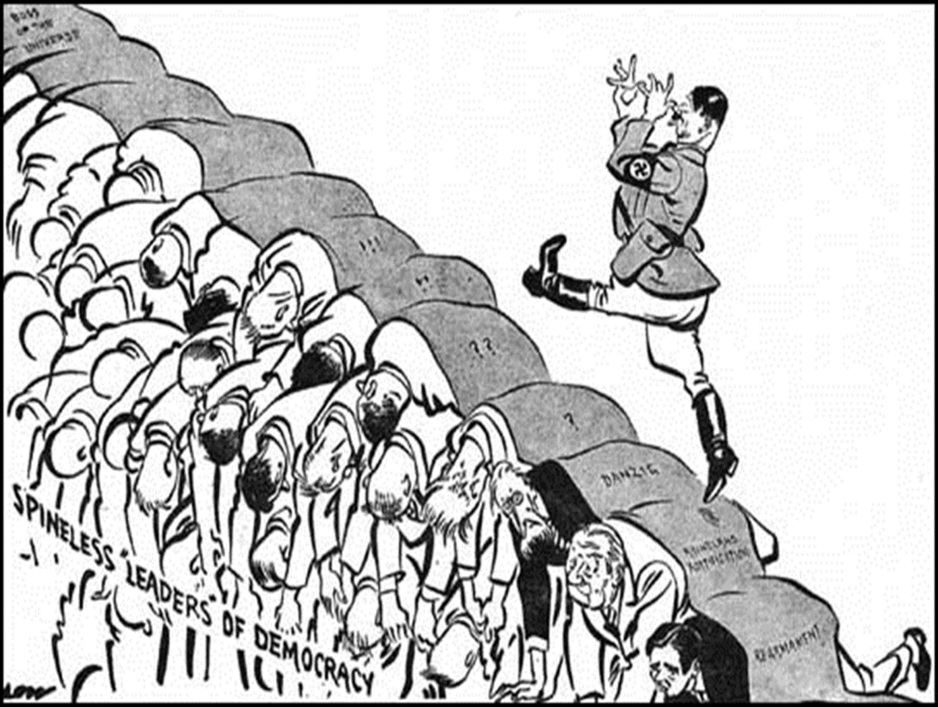

German Aggression
- Aug. 1939 ____________ signs the ____ - ____________ Pact with USSR
  - Attempts to hold off a _____- ________ war
- September 1,1939 invades Poland using “_____________”
- Sept. 3, 1939 Great Britain and ____________ declare war on Germany
- Sept. 17 , 1939 USSR invaded ________ (part of non-aggression pact) then moves into Lithuania, ________, Estonia and ____________
- The War Begins
The War Begins
After Hitler invades ______________________, France and Great Britain declare war on Germany
The War Begins
Before ___________ and __________________ could respond, ______________ fell.
Hitler annexed the _____________ half of Poland which had a large _______ population
This was the first use of __________________, fast-moving ____________ and ___________ followed by massive _______________ forces to take the enemy by ____________ and quickly overwhelm them
The War Continues
- Sept. 17, 1939 ____________ sends Soviet troops to occupy the ___________ part of Poland
- ___________, ____________ and _____________ fell
- _____________fought fiercely but eventually had to surrender
- The _______ _________ or “Sitzkrieg”
  - French and British mobilized along the ___________ ____________ and waited for a German attack
  - _______________ – the calm ended and Hitler invades ___________ and ___________
Rescue at Dunkirk
- Germans___________ had trapped the Allied forces at ___________- outnumbered, outgunned, and pounded from the air
- Trapped with their backs to the ___________.
- Rescue was one of the most ___________ acts of the war
- A fleet of about ___________ ships were sent across the ___________ Channel to Dunkirk.
- Royal Navy ships, civilian craft—___________, lifeboats, ___________, paddle steamers, and ___________ boats—joined the rescue effort.
- May 26 to June 4, under heavy fire from German bombers, boats sailed back and forth from Britain to Dunkirk.
- Boats carried some ___________battle-weary soldiers to safety.
- https://www.youtube.com/watch?v=2b0hNjdbwc4
The Fall of France
- The Germans invaded __________ in __________
- Months later all of France had fallen to the Nazis
- __________________________ escaped to Great Britain to strategize how to get France back
- 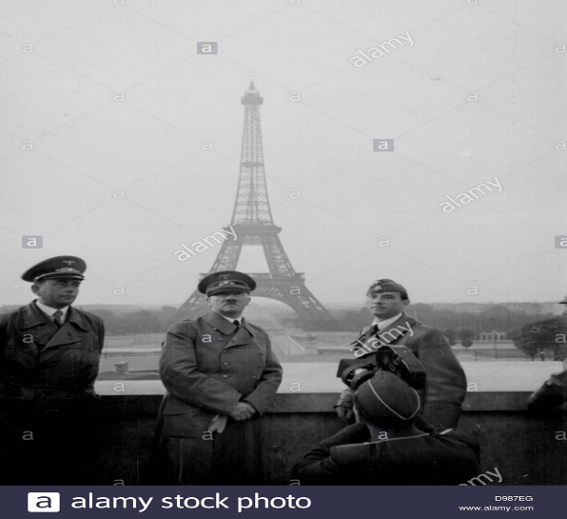
Hitler Invades the Soviet Union
- Operation Barbarossa
  - June 22, 1941 – ____________ tanks and aircraft invade
  - Soviet Union _____________
  - troops ill-equipped and untrained
  - Within weeks, Germany had pushed ________ miles into the Soviet Union
  - Soviet Union practiced the ________ ________ _________ as they retreated
  - City of ____________ under siege
  - ______ ____________ people starved to death in winter of 1941-1942
  - Leningrad __________ to _____________

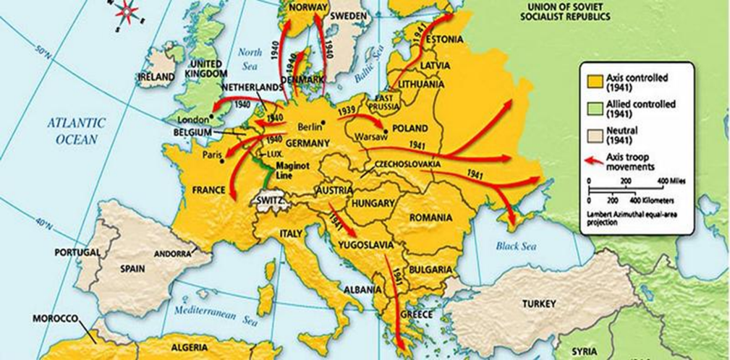
Battle of Britain
- Germans set out a ______________ operation in Great Britain
- The bombing of Britain lasted for months
- British never ___________________

United States Neutrality
- Neutrality Acts declared the US would _____________________________
- American were fearful of getting involved in another _____________________________
- Started _____________ and _______________ policy
FDR’s Garden Hose
- “If your neighbor’s house is on fire you would let him borrow your garden hose.”
- FDR started the “ ___________________________” – loaned war materials to the Allies
Japanese Attack
- The Japanese Empire set out to conquer _____________________
- The US was in their way
- December 7, 1941 the Japanese attacked the US at ________ _________ in the Pacific Ocean
US Enters the War
- December 8, 1941 US declares war on ________________
- December 11, 1941 ___________________ declares war on the United States
The American Home Front
- The United States government stirs patriotic feelings
- Movies are used to build morale
- ___________________ is used to keep war effort going
- People rationed goods/supplies and started _____________________
The American Home Front
- To raise money to fight the war the U.S. issued _______________.
- A bond is like lending the government money.
Japanese Americans
- Many Japanese Americans served heroically for the US in World War II
- The _________________ received high honors and awards of distinction for bravery
Japanese Americans Interned
- Many Americans were distrusting of Japanese Americans
- Thousands of Japanese Americans were forced into ______________________ in the Midwest throughout WWII

African Americans in the Military
https://www.history.com/topics/world-war-ii/tuskegee-airmen
Navajo Code Talkers
https://www.youtube.com/watch?v=rO5-14p7ccI

Invasion of the Soviet Union
Hitler broke the non-aggression pact and invaded the Soviet Union
- Germans wanted to obtain the ______________________ quickly
- The Germans were __________________ in the winter months
Stalingrad
- Germans tried to ___________ Russian city of Stalingrad
- Russians pushed the Germans out of Stalingrad
- Turning point on the ______________________

El Alamein
- In 1942 German forces tried to seize ___________ and the ____________________
- British forces pushed ____________________ out
- Turning point in ________________
1943 - Invasion of Italy - Fall of Italy
- Allies moved to ________
- _____________________ was overthrown and moved his government to _______________
- Allies freed Northern Italy
- Mussolini was shot and killed by Italians
D - Day Invasion
- _________________ Allies open operation to free France
- Landed on the Beaches of Normandy under the command of ___________________
- Heavy loss of life but successful in freeing France
Battle of the Bulge
- Nazi’s last _______________________
- Attacked area between ____________ and _________________
- US soldiers attacked from the rear and defeated the ____________________
FDR Dies in Office April 1945
Victory in Europe Day
- Soviet army surrounded ____________
- _________ ___________________ to Eisenhower
- May 7, 1945: ___________
- Hitler ___________ to surrender and commits suicide

The Holocaust
- Nazis proposed a new racial order
- Germanic people or ______________ were a “_________________________”
- All other people ____________, particularly the ______; also, _____________, __________, _____________________
- Long _____________ ______________ of hatred for Jews
- Hitler made the targeting of Jews a ___________________ ______________
- ______________________________: deprived Jews of their ________________ citizenship and forbade marriage between Jews and non-Jews
The Holocaust
- ____________________ – the “night of broken glass”
- Violent attack on the ____________ _______________
- Nazi storm troopers attacked Jewish homes, businesses and synagogues
- Close to ___________ were killed
- Some Jews left, others remained
- Hitler favored _______________
  - But France, Britain and the U.S. closed their doors after admitting tens of thousands
- The Holocaust
- Isolating the Jews
  - Emigration of Jews did not solve “the ___________________” so….
  - All Jews ordered into designated _________________ in cities sealed off with barbed wire and stone walls
  - Hoped they would die of ___________ and ________________
- The Holocaust
- The “____________________”
  - Hitler grew impatient
  - Program of _______________ was begun, the ____________________ of an entire people
  - SS moved from town to town hunting down Jews
  - Others taken to _________________________ or _________________ camps mainly in Germany and Poland
- The Holocaust
- The Final Solution reached its last stage in 1942
  - Nazis built ________________________ equipped with huge gas chambers – capable of killing ________________ human beings a day
  - _________________ European Jews were died
  - Only ___ % of Polish Jews survived
  - Only ___% of Germany/Austrian Jews survived
  - Only ___% of Russian Jews survived
Hitler’s Final Solution
- Anti – Semitism: hatred of Jews
- Holocaust
- People effected:
  - Jews, Poles, Slavs, Gypsies, homosexuals, disabled, mentally ill
  - Mobile Killing Units
  - https://www.ushmm.org/wlc/en/media_nm.php?MediaId=8862

War in the Pacific
- Focus turns to __________
- US begins “_________________________” beginning with Guadalcanal
- Capture islands getting closer to Japan
- Japan begins to ____________

War in the Pacific
- Focus turns to Japan
- US begins “Island Hopping” beginning with Guadalcanal
- Capture islands getting closer to Japan
- Japan begins to retreat
US Pacific Island Campaigns
Japan’s Last Effort
Battle of Leyte Gulf
Japanese plan to destroy the American fleet so Allies could not resupply their ground troops
Disastrous results – within 4 days, Japanese navy was eliminated
Only Kamikaze (suicide) pilots and army stood between the Allies and Japan
Allies Move Closer
http://www.history.com/topics/world-war-ii/battle-of-iwo-jima/videos/battle-of-iwo-jima?m=528e394da93ae&s=undefined&f=1&free=false
http://www.history.com/topics/world-war-ii/battle-of-okinawa/videos/battle-of-okinawa?m=528e394da93ae&s=undefined&f=1&free=false
Iwo Jima - 760 miles from Tokyo
Okinawa - 350 miles from southern Japan
IWO JIMA http://www.history.com/topics/world-war-ii/battle-of-leyte-gulf/videos/battle-of-iwo-jima?m=528e394da93ae&s=undefined&f=1&free=false
Japan Surrenders
Truman told that invasion of Japan would cost 500,000 lives
Decides to use a powerful new weapon developed by the Manhattan Project
Atomic Bombs
Hiroshima
Nagasaki
http://www.history.com/topics/world-war-ii/bombing-of-hiroshima-and-nagasaki/videos/coroners-report-atomic-bomb
https://www.youtube.com/watch?v=ncq_Wye43TM
https://www.youtube.com/watch?v=jY9VwCE_Dsg
Victory Over Japan Day
Effects of World War II
- Geneva Convention
  - Set guidelines for POWs
- Formation of Israel
  - Jewish Nation
- Creation of United Nations
  - Prevent future wars

The War Ends
Yalta Conference
Big Three (Great Britain, USSR, and the U.S.)
Yalta Declaration
Create a world organization to help deal with problems peacefully – the United Nations
Provide democracy in liberated nations
Dismember Germany - Divide Germany into 4 zones
Provide trial of war criminals
Effects of WWII
Soviet Union 22 million dead
Germany 8 million dead
Japan 2 million dead
USA 300,000 dead
Jews 6 million dead
Over 55 million dead
Most destructive war in history
War Criminal Trials
Nuremburg, Germany
Nov. 1945 – Sept. 1946
Nazi war criminals
“Crimes against humanity”

