NAPOLEON

- Napoleon Bonaparte – Hero or Tyrant?
- 1. How did Napoleon take power?
- Gained __________ experience and proved to be a ___________
  - sent to military school
  - joined the army of the new Revolutionary government
- His “______ ________” (what does this word mean??)
  - “a __________ to the ________”
  - By 1799, the ____________ lost control
  - Napoleon seizes __________ _____________

- 2. Napoleon’s Government
- Established a group of _______ ______, one of whom was ____________.
- Napoleon became _______ ________, had the powers of a _____________.
    - People accepted him - he finally brought ____________ to France
      - In 1802, __________, _________ and _____________ signed peace agreements with France

- 3. Napoleon Rules France
- Restoring Order at Home
  - Kept many of the _________ of the ______________; strengthened the ______________ government
  - First task – improve the _______________
    - efficient method of _______ ________________
    - _____________ _____________ ______________
  - Second task - end the ___________ and __________ of the _________________
    - Dismissed ____________ officials
    - Set up ____________, or government-run public schools, to provide the government with ______________ ______________.

- 4. Napoleon Rules France
- Restoring Order at Home
  - Ignored the changes the Republic made towards religion
    - __________ - recognized the influence of the Church, but rejected Church control in national affairs
  - ______________ __________
    - system of _________ ___________that eliminated many injustices
    - Limited ____________ and promoted _______ and ___________ over ____________ rights; freedom of ____________
    - Restored ____________ in the French colonies of the Caribbean.

- 5. Napoleon Creates an Empire
- 1804, Napoleon decided to make himself __________, and the French voters ____________ him
- He __________ himself, indicating he was more __________ than the ____________
- He wanted to be more than just the emperor of _____________.
  - But wars and lack of money prevented this

- 6. Napoleon Creates an Empire
- Conquering Europe
  - annexed the Austrian _________ and parts of _____ and ___________
  - Continued to conquer his enemies
    - His battlefield successes forced the rulers of Austria, Prussia, and Russia to sign ____________ __________.
  - Able to build the largest _____________ empire since the _______________
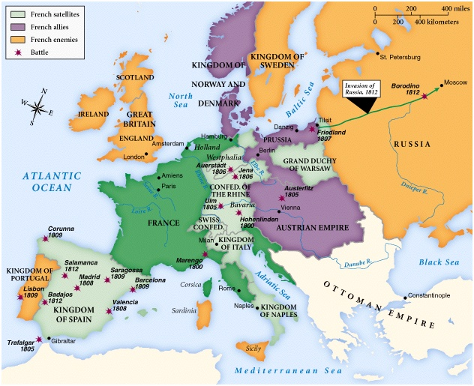
- 7. Napoleon’s Empire
- Battle of Trafalgar
- Only major enemy left: __________ ___________
  - Battle of _____________ (southwest coast of Spain)
    - Only major battle Napoleon ____________
    - British commander, Horatio Nelson, split the larger French fleet, capturing many ships
    - The destruction of the French fleet had two major results:
    - Ensured the __________ of the _________ navy for the next 100 years.
    - Forced ____________ to give up his plan of invading __________________.

- 8. The French Empire
- By 1812, only areas of Europe free from Napoleon’s control were ________, _________, Sweden, and the Ottoman Empire
- Also controlled numerous independent countries
- At this point the French Empire is ______ but very _________
- After 1812, it will quickly fall to pieces

- 9. Napoleon’s Empire Collapses
- Napoleon’s Costly Mistakes
  - The _________________ _____________
    - ____________ to prevent ___________ and _____________ between ________ __________and other European nations
    - Supposed to make continental Europe more _____ __________ and destroy Great Britain’s commercial and __________l economy
    - _________
      - ___________ were able to bring cargo from Britain into Europe
      - It __________ British trade, it did not destroy it

- 10. Napoleon’s Empire Collapses
- The _______________ War
  - Napoleon invaded ___________ to force acceptance of the Continental System
  - put his own _________ on the throne
  - Angered the Spanish people and inflamed ____________ feelings
  - Bands of peasant fighters, ___________, along with British troops struck at French armies in Spain
  - Napoleon lost about ____________ men
    - Weakened the _______________
- In Spain and elsewhere, loyalty to one’s own country started to become a powerful weapon against Napoleon

- 11. Napoleon’s Empire Collapses
- The Invasion of _____________
  - In 1812, ________ between Russia and France broke down
  - June 1812, Napoleon and his ________ _________(420,000 men) marched into ____________
  - As Napoleon advanced, Alexander pulled back his army
    - practiced a __________-_________ ___________
  - Napoleon arrives in ___________; city was in flames
  - Retreat in Oct. - suffered from the snow and cold
  - Russian raiders attacked them
  - Many soldiers killed or died from their wounds, exhaustion, hunger, and cold

- 12. Napoleon’s Downfall
- Because Napoleon was weak, , ___________, __________, ___________, and Sweden joined forces against him
- Napoleon managed to raise another army.
  - They were __________ and ill prepared for battle
- Allied forces easily _____________his army.
- April __________, he accepted the terms of ___________ and gave up his __________
  - exiled to ___________

- 13. The Hundred Days
- _________ ____(Louis XVI’s brother) assumed the throne.
  - __________ among his subjects, especially peasants
  - Worried he would undo the Revolution’s land reforms
- Napoleon _________ from Elba and landed in France in March 1815
  - Within days he was again the ___________ __ __________.
- ___________ allies quickly responded.
- prepared for battle at __________ in __________.
- June 20, 1815, Napoleon is ________ by ________ and ___________ armies

- 14. Napoleon’s Legacy
- Napoleon was a ________ _________ and a __________ administrator
- However, all his victories and other achievements must be measured against the _________ of lives that were lost in wars
- Napoleon’s ___________ opened the door for the freed European countries to establish _____ ________

