Life during the Industrial Revolution
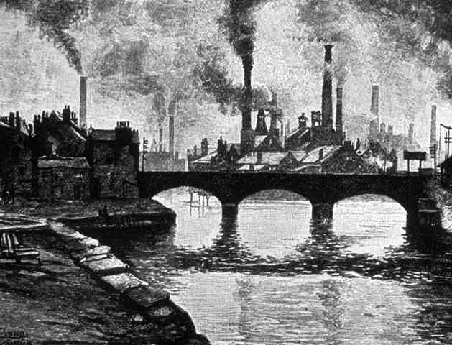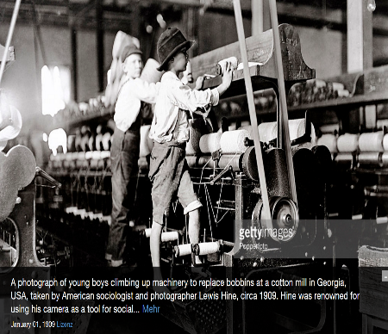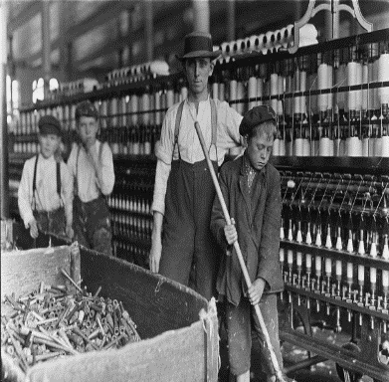
You and members of your group will be researching an assigned topic concerning the Industrial Revolution
Your job will be to create a poster that will give in-depth information on your topic which you will present to the class. You will have two - three days in class to work on this. You will present your posters on Thursday.
You will be given different readings concerning your topic. You are to look through these readings and decide what is important enough for your classmates to know and include that on your posters.
You are to become an EXPERT on your assigned topic!!!

Your poster must thoroughly cover your topic and include five pictures. You can hand draw them or print them from the internet.

Rubric:
 | 4 Excellent | 3 Good | 2 Fair | 1 Poor | 0
Thoroughness of Info x 6
Pictures x 1
Neatness x 1
Presentation
x 1
Total

/36 =

