Industrialization Revolution – Spring 2018 Unit 11
Multiple Choice - Choose the best answer.

_____1. Which areas of Britain grew the most?
- Countryside b. Coastal ports c. Urban areas d. Near rivers
_____ 2. Which industry saw the earliest benefit of innovations?
a. The textile industry b. The railways c. The agriculture industry d. factories

_____ 3. What were the three factors of production required for industrialization?
- land, labor capital
- government, military, colonies
- raw materials, natural resources, and man-made goods

_____ 4. A major result of the Industrial Revolution was the
- concentration of workers in urban areas
- increased desire of the wealthy class to share its power
- control of agricultural production by governments

_____ 5. Which of the following did NOT improve as an early result of the Industrial Revolution?
- Factory working conditions.
- The quality of clothing.
- The average person’s diet.

_____ 6. How did the Agricultural Revolution lead to the Industrial Revolution?
- It led to population growth.
- It increased food supplies.
- It caused farmers to lose land and seek other work.
- All of the above are true.

_____ 7. What impact did technological advances have on industry?
- Production of goods increased.
- Quality of products decreased.
- Number of factory workers decreased.

Matching Select the letter of the term, name, or phrase that best matches each description. Note – some letters may not be used at all; some may be used more than once.

- Industrial Revolution B. Enclosure C. Urbanization D. Decentralization E. Ruralization

_____ 8. A fenced-in field created by wealthy British landowners on land that was formerly worked by village farmers.
_____ 9. The shift from man-made goods to machine-made goods.
_____10. The movement of people from rural areas to the city.

Multiple Choice Choose the best answer.

_____ 11. Why was the four field system successful?
- It made the fields easier to plow and fertilize.
- It increased the amount of people needed to work in the fields.
- It increased the amount of food produced.

_____ 12. Which of the following is a social impact of the railways?
- People were able to travel greater distances for leisure.
- Newspapers could be sent from London all over the country; the post was speed up.
- New foods were brought by the railway.
- All of the above are true.

_____ 13. Which device allowed one person to spin many threads at once, further increasing the amount of finished cotton that a worker could produce?
- Seed Drill b. the Loom c. Spinning Jenny

_____ 14. Who invented the first process for mass-producing steel inexpensively?
- Eli Whitney b. Abraham Darby c. Henry Bessemer

_____ 15. How did factory work give women new opportunities?
- It allowed women to earn more money than men.
- It convinced the government to allow women to vote.
- It gave them a new job opportunities and a sense of independence.

_____ 16. In what industry did most women work?
- Banking b. Coal Mines c. Textile

_____ 17. Why were women and children often hired instead of men?
- Women and children were smarter than male workers.
- Women and children were willing to work for lower wages than male workers.
- Women and children were thought to be more talented than male workers.

____ 18. Why was Britain a perfect setting for the beginning of an Industrial Revolution?
a. It had many resources
b. It had a large population
c. It had a politically stable government
d. a and b
e. All of the above.

_____ 19. Who improved on the steam engine so that it worked faster and with less fuel?
a. John Kay b. Robert MacAdam c. Robert Fulton

_____ 20. How did the Industrial Revolution affect cities?
a. It created technology to clean the air.
b. It made them lose valuable sources of food.
c. It made the population grow faster than the housing supply.

_____ 21. What was a benefit of the railroad in Britain?
a. It eliminated hundreds of thousands of jobs.
b. It offered cheap transportation for materials and goods.
c. It provided people with a slower way of travel.

_____ 23. The crop rotation system that developed in Britain during the agricultural revolution increased crop yields
a. by allowing more land to be used
b. by increasing nutrients in the soil
c. by allowing crops to be planted all in the same field

_____ 24. All of the following were results of the agricultural revolution in Britain EXCEPT that
a. population increased.
b. the number of farmers increased.
c. the average size of farms increased.

____ 25. Which of the following was TRUE of the condition of the workers during the early Industrial Revolution?
  - They were treated well by their employers
  - They made little money and worked long hours in poor working conditions
c. Their life expectancy increased

____ 26. Which of the following statements about the 19th century textile industry is FALSE?
a. The widespread use of child labor b. An all-male workforce
c. Dangerous and dirty working conditions

____ 27. This picture shows
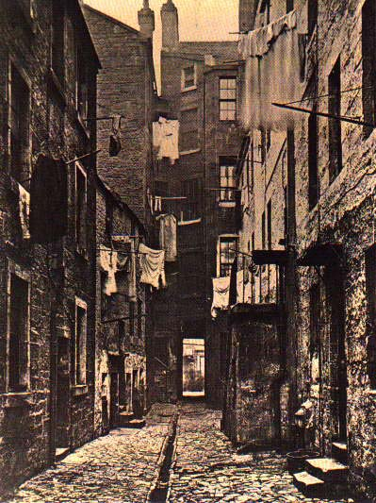

a. a tenement b. the domestic system c. the factory system

____ 28. This picture shows

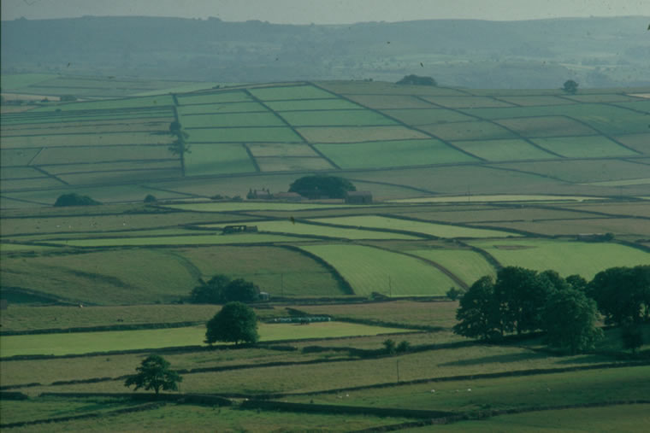

a. farming in England before Industrialization
b. a tenement
c. the enclosure movement

____ 29. What machine wove cloth and ended the cottage industries?
a. the power loom b. the cotton gin c. the external combustion engine

____ 30. What do the flying shuttle, spinning jenny, and water-powered loom have in common?
a. They allowed textiles to be mass-produced for a cheaper price
b. They enabled cottage industries to do more work at home
c. They utilized steam power to run the machines

____ 31. One result of the invention of the cotton gin was
a. a cleaner, seedless cotton could be grown
b. less cotton could now be planted
c. an increase in slavery

32 - 33. Name two reasons why employing children in factories was beneficial to the factory owner.

______________________________________________________________________

_____________________________________________________________________

34 - 35. Name two ways in which society was affected during the Industrial Revolution.

________________________________________________________________

________________________________________________________________

