Effects of the Industrial Revolution
- Working Conditions
- Living Conditions
- Urbanization
- Child Labor

Now that we have looked at how and why the Industrial Revolution occurred, it’s time to consider its effects on people. We learned that industrial production increased tremendously, bringing wealth and power to Great Britain throughout the 19th century. But we have yet to explore the effects of industrialization on society, on the daily living and the working conditions of common people. What was life like for the average industrial worker? Was living in a new industrial city and working in a factory an improvement over life in the countryside? Did the new factory life change for the better the roles of family members, including women and children? Were people healthier? In general, did the Industrial Revolution improve life for most people? To answer these questions, we’ll look at various primary source accounts to gather evidence from the people that actually lived through this time period.
Since the Industrial Revolution was so new at the end of the 18th century, there were initially no laws to regulate new industries. For example, no laws prevented businesses from hiring seven-year-old children to work full time in coal mines or factories. No laws regulated what factories could do with their biohazard waste. Free-market capitalism meant that the government had no role in regulating the new industries or planning services for new towns. And those who controlled the government liked it that way—only a small minority of people, the wealthiest, could vote in England at this time. So during the first phase of the Industrial Revolution, between 1790 and 1850, British society became the first example of what happens in a country when free-market capitalism has no constraints. You will learn about the effects of the Industrial Revolution on living and working conditions, urbanization (the growth of cities), child labor, public health, working class family life, the role of women, the emerging middle class, and economic growth and income. You will be asked to reflect about what role, if any, the government should have taken to improve life in the new industrial cities.

Working conditions
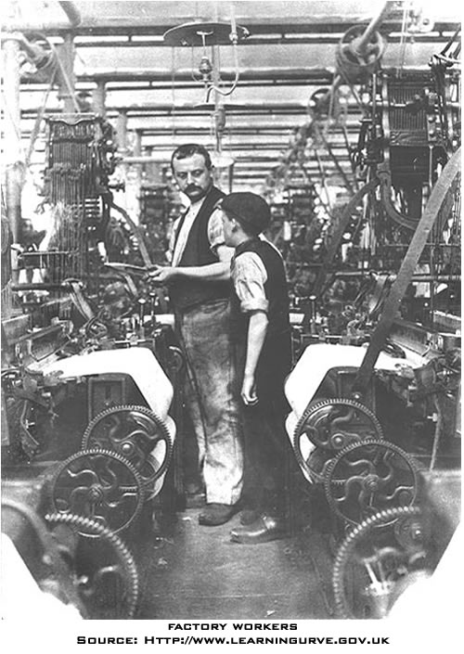
What were the working conditions like during the Industrial Revolution? Well, for starters, the working class—who made up 80% of society—had little or no bargaining power with their new employers. Since population was increasing in Great Britain at the same time that landowners were enclosing common village lands, people from the countryside flocked to the towns and the new factories to get work. This resulted in a very high unemployment rate for workers in the first phases of the Industrial Revolution. Henry Mayhew, name his title or role, studied the London poor in 1823, and he observed that “there is barely sufficient work for the regular employment of half of our labourers, so that only 1,500,000 are fully and constantly employed, while 1,500,000 more are employed only half their time, and the remaining 1,500,000 wholly unemployed” (Thompson 250). As a result, the new factory owners could set the terms of work because there were far more unskilled laborers, who had few skills and would take any job, than there were jobs for them. And since the textile industries were so new at the end of the 18th century, there were initially no laws to regulate them. Desperate for work, the migrants to the new industrial towns had no bargaining power to demand higher wages, fairer work hours, or better working conditions. Worse still, since only wealthy people in Great Britain were eligible to vote, workers could not use the democratic political system to fight for rights and reforms. In 1799 and 1800, the British Parliament passed the Combination Acts, which made it illegal for workers to unionize, or combine, as a group to ask for better working conditions.
Many of the unemployed or underemployed were skilled workers, such as hand weavers, whose talents and experience became useless because they could not compete with the efficiency of the new textile machines. In 1832, one observer saw how the skilled hand weavers had lost their way and were reduced to starvation. “It is truly lamentable to behold so many thousands of men who formerly earned 20 to 30 shillings per week, now compelled to live on 5, 4, or even less” (284).
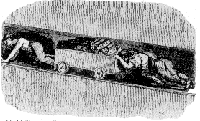
For the first generation of workers—from the 1790s to the 1840s—working conditions were very tough, and sometimes tragic. Most laborers worked 10 to 14 hours a day, six days a week, with no paid vacation or holidays. Each industry had safety hazards too; the process of purifying iron, for example, demanded that workers toiled amidst temperatures as high as 130 degrees in the coolest part of the ironworks (Rosen 155). Under such dangerous conditions, accidents on the job occurred regularly. A report commissioned by the British House of Commons in 1832 commented that "there are factories, no means few in number, nor confined to the smaller mills, in which serious accidents are continually occurring, and in which, notwithstanding, dangerous parts of the machinery are allowed to remain unfenced" (Sadler). The report added that workers were often "abandoned from the moment that an accident occurs; their wages are stopped, no medical attendance is provided, and whatever the extent of the injury, no compensation is afforded" (Sadler). As the Sadler report shows, injured workers would typically lose their jobs and also receive no financial compensation for their injury to pay for much needed health care.
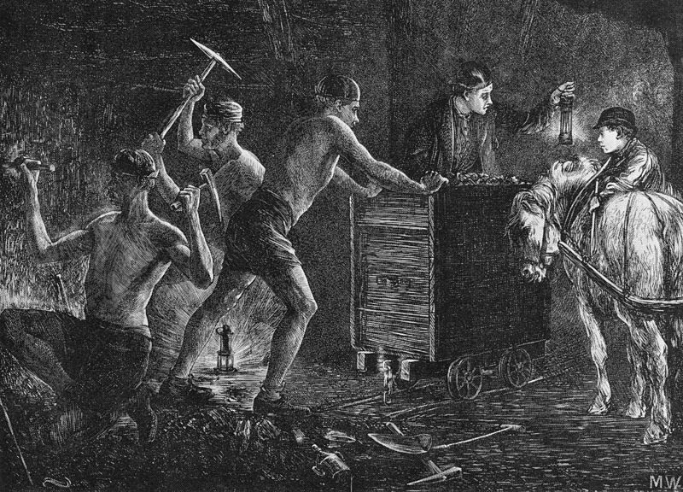
Life in the factory was most challenging for the first generation of industrial workers who still remembered the slower and more flexible pace of country life. Factory employers demanded a complete change of pace and discipline from the village life. Workers could not wander over to chat with their neighbors or family as they would have done while working in the country. They could not return to the village during harvest time to help their families, unless they wanted to lose their jobs. Instead, they were no longer their own bosses; foremen and overseers supervised a new working culture to insure that workers’ actions were focused and efficient. A few workers were able to improve their lot by going into business for themselves or winning a job as a supervisor, but the majority saw very little social mobility.

Living conditions
Working in new industrial cities had an effect on people’s lives outside of the factories as well. As workers migrated from the country to the city, their lives and the lives of their families were utterly and permanently transformed.
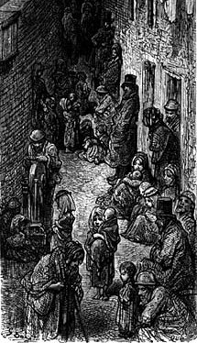
For many skilled workers, the quality of life decreased a great deal in the first 60 years of the Industrial Revolution. Skilled weavers, for example, lived well in pre-industrial society as a kind of middle class. They tended their own gardens, worked on textiles in their homes or small shops, and raised farm animals. They were their own bosses. One contemporary observer noted, “their dwelling and small gardens clean and neat, —all the family well clad, —the men with each a watch in their pocket, and the women dressed in their own fancy, —the Church crowded to excess every Sunday, —every house well furnished with a clock in elegant mahogany or fancy case. . . . Their little cottages seemed happy and contented. . . . it was seldom that a weaver appealed to the parish for a relief. . . . peace and content sat upon the weaver’s brow” (Thompson 269). But, after the Industrial Revolution, the living conditions for skilled weavers significantly deteriorated. They could no longer live at their own pace or supplement their income with gardening, spinning, or communal harvesting. For skilled workers, quality of life took a sharp downturn: “A quarter [neighborhood] once remarkable for its neatness and order; I remembered their whitewashed houses, and their little flower gardens, and the decent appearance they made with their families at markets, or at public worship. These houses were now a mass of filth and misery“ (269).
In the first sixty years or so of the Industrial Revolution, working-class people had little time or opportunity for recreation. Workers spent all the light of day at work and came home with little energy, space, or light to play sports or games. The new industrial pace and factory system were at odds with the old traditional festivals which dotted the village holiday calendar. Plus, local governments actively sought to ban traditional festivals in the cities. In the new working-class neighborhoods, people did not share the same traditional sense of a village community. Owners fined workers who left their jobs to return to their villages for festivals because they interrupted the efficient flow of work at the factories (Stearns 73-74). After the 1850s, however, recreation improved along with the rise of an emerging the middle class. Music halls sprouted up in big cities. Sports such as rugby and cricket became popular. Football became a professional sport in 1885. By the end of the 19th century, cities had become the places with opportunities for sport and entertainment that they are today (Hobsbawm, Industry and Empire 164).
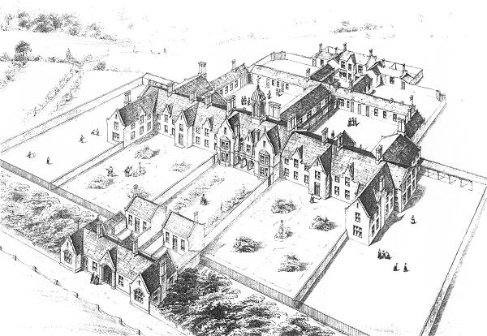
During the first 60 years of the Industrial Revoltuion, living conditions were, by far, worst for the poorest of the poor. In desperation, many turned to the “poorhouses” set up by the government. The Poor Law of 1834 created workhouses for the destitute. Poorhouses were designed to be deliberately harsh places to discourage people from staying on “relief” (government food aid). Families, including husbands and wives, were separated upon entering the grounds. They were confined each day as inmates in a prison and worked every day. One assistant commissioner of the workhouses commented, “Our intention is to make the workhouses as much like prisons as possible.” Another said, “Our object is to establish a discipline so severe and repulsive as to make them a terror to the poor and prevent them from entering” (Thompson 267). Yet, despite these very harsh conditions, workhouse inmates increased from 78,536 in 1838 to 197,179 in 1843 (268). This increase can only be viewed as a sign of desperation amongst the poorest of the poor.

Urbanization
One of the defining and most lasting features of the Industrial Revolution was the rise of cities. In pre-industrial society, over 80% of people lived in rural areas. As migrants moved from the countryside, small towns became large cities. By 1850, for the first time in world history, more people in a country—Great Britain—lived in cities than in rural areas. As other countries in Europe and North America industrialized, they too continued along this path of urbanization. By 1920, a majority of Americans lived in cities. In England, this process of urbanization continued unabated throughout the 19th century. The city of London grew from a population of two million in 1840 to five million forty years later (Hobsawm, Industry and Empire 159).
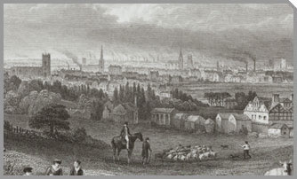
The small town of Manchester, England also grew rapidly and famously to become the quintessential industrial city. Its cool climate was ideal for textile production. And it was located close to the Atlantic port of Liverpool and the coalfields of Lancashire. The first railroads in the world later connected the textile town to Liverpool. As a result, Manchester quickly became the textile capital of the world, drawing huge numbers of migrants to the city. In 1771, the sleepy town had a population of 22,000 . Over the next fifty years, Manchester’s population exploded and reached 180,000 ( “A History of Manchester”). Many of the migrants were destitute farmers from Ireland who were being evicted from their land by their English landlords. In Liverpool and Manchester roughly 25 to 33 percent of the workers were Irish. (Thompson 429).
This process of urbanization stimulated the booming new industries by concentrating workers and factories together. And the new industrial cities became, as we read earlier, sources of wealth for the nation.
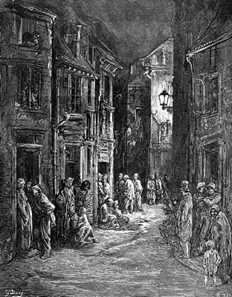
Despite the growth in wealth and industry urbanization also had some negative effects. On the whole, working-class neighborhoods were bleak, crowded, dirty, and polluted. Alexis de Tocqueville, a French traveller and writer, visited Manchester in 1835 and commented on the environmental hazards. “From this foul Drain the greatest stream of human industry flows out to fertilize the whole world. From this filthy sewer pure gold flows. Here humanity attains its most complete development and its most brutish, here civilization works its miracles and civilized man is turned almost into a savage.” (Hobsbawm, The Age of Revolution 44)

Child Labor
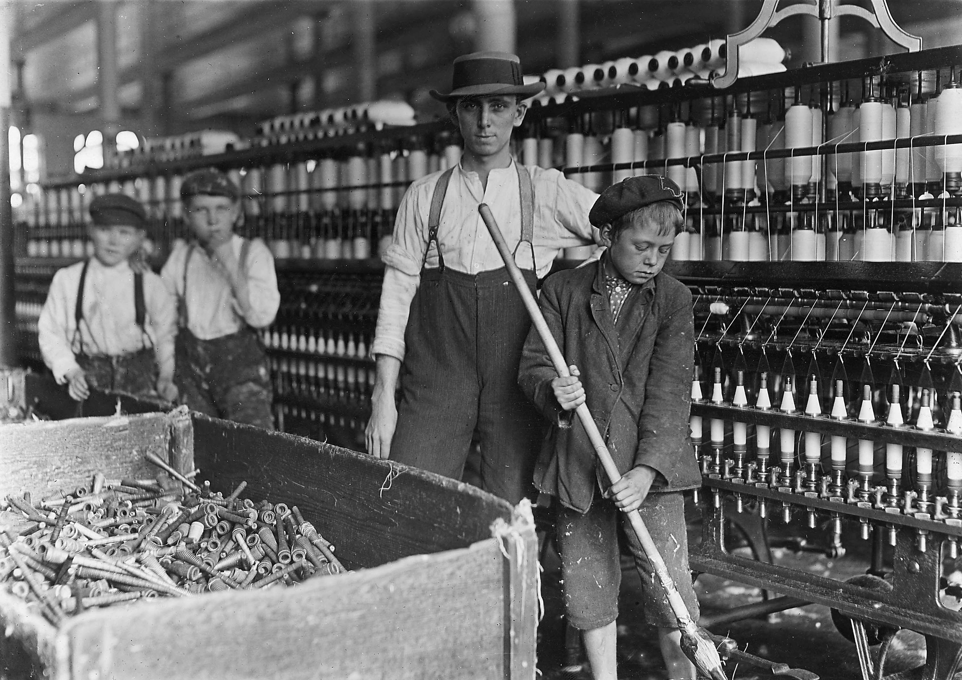

Child labor was, unfortunately, integral to the first factories, mines, and mills in England. In textile mills, as new power looms and spinning mules took the place of skilled workers, factory owners used cheap, unskilled labor to decrease the cost of production. And, child labor was the cheapest labor of all. Some of these machines were so easy to operate that a small child could perform the simple, repetitive tasks. Some maintenance tasks, such as squeezing into tight spaces, could be performed more easily by children than adults. And, children did not try to join workers unions or go on strike. Best of all, they were paid 1/10 of what men were paid. It’s not surprising, then, that children were heavily employed in the first factories in history. In 1789, in Richard Arkwright’s new spinning factory, two-thirds of 1,150 factory workers were children. (Ashton 93)
The tedious and dangerous factory work had negative effects on the health of children. Doctor Turner Thackrah described the children leaving the Manchester cotton mills as “almost universally ill-looking, small, sickly, barefoot and ill-clad. Many appeared to be no older than seven. The men, generally from sixteen to twenty-four, and none aged, were almost as pallid and thin as the children” (Thompson 329) Observations such as these slowly made their way to the British government.
In the 1830s, the British Parliament began investigating the conditions in factories for children. One Member of Parliament, Michael Sadler, started a committee, in 1832, to send investigators out to factories to interview children and gather evidence about their working conditions. Sadler sought to pass a bill through Parliament to decrease child labor and regulate all factories to have a 10-hour work day. The transcripts from these investigations survive today as some of the best primary source evidence of child labor. Read the following accounts.

